

**Case Study on Apple and Microsoft**

**Introduction to Management**

**APD1F2011CS(IS)**

**DATE ASSIGNED** : 21st January 2021

**DUE DATE** : 15th February 2021

**MODULE CODE** : BM007-3-1-IMT-T7

**ASSIGNMENT** : Documentation on the organizational structure of two organizations

**LECTURER** : Gobinathan Manickam

GROUP MEMBERS:

|  |  |  |
| --- | --- | --- |
| **No.** | **Name** | **TP Number** |
| 1 | MOHAMMAD TABISH AMJAD (LEADER) | TP062145 |
| 2 | MUHAMMAD AKMAL BIN KASHRY | TP062672 |
| 3 | ESLAM MAGDY REZK EBRAHIM HASSANIN | TP062816 |
| 4 | NAVEN SHRI A/L ARIVALAGAN | TP058295 |
| 5 | KELVINJIT SINGH A/L LAKHBIR SINGH | TP056599 |

**Table of Contents**

Table of Figures: 4

Abstract: 5

Introduction: 6

**Organizational Elements:** 6

Formalization: 6

What is formalization? 6

Apple: 6

Microsoft: 7

Effectiveness: 7

Centralization: 7

What is departmentalization? 7

Apple: 8

Microsoft: 8

Effectiveness: 8

Span of Control: 9

What is Span of Control? 9

Apple: 9

Microsoft: 9

Effectiveness: 9

Departmentalization: 10

What is departmentalization? 10

Apple: 10

Microsoft 10

Effectiveness: 10

Conclusion: 12

Limitations: 12

Appendix A: Graphics and Figures 13

References 18

# Table of Figures:

Figure 1: Microsoft's Logo (Warren, 2012) 6

Figure 2: Apple's Logo (1000 Logos, 2021) 6

Figure 3: Apple's Organizational Structure Chart (Pen My Paper, n.d.) 13

Figure 4: Microsoft's Organizational Structure Chart (CBInsights, n.d.) 14

Figure 5: Departmentalization in Microsoft (Dudovskiy, 2019) 15

Figure 6: Departmentalization in Apple (Dudovskiy, 2021) 16

# Abstract:

This documentation compares Apple and Microsoft, critically analyzing the various elements of organizational structure, detailing their effectiveness, and highlighting any changes necessary for improvement. The purpose of the document is to elaborate how technology companies, can internally function differently, yet still manage to outperform most of their competitors despite sharing the same volatile market they specialize in.

# Introduction:

|  |  |  |
| --- | --- | --- |
|  | **Apple** | **Microsoft** |
| **Logos** | Microsoft logo  Figure 1: Microsoft's Logo (Warren, 2012) | Figure 2: Apple's Logo (1000 Logos, 2021) |
| **Founders** | Steve Jobs, Steve Wozniak, and Ronald Wayne | Bill Gates and Paul Allen |
| **Location of Headquarters** | Cupertino, California | Redmond, Washington |
| **Basis of Business Model** | Innovation and Consumer-centric devices (Ross, 2020) | Software Licensing and Cloud services (Christensson, 2018) |
| **Latest Revenue Reports (2021 Q1)** | 111.4 Billion USD (Apple, 2021) | 37.2 Billion USD (Microsoft, n.d.) |
| **Change in Revenue (compared to 2020 Q1)** | 21% Increase (Apple, 2021) | 12% Increase (Microsoft, n.d.) |

# **Organizational Elements:**

# Formalization:

## What is formalization?

Formalization in organizations refers to the extent to which rules or procedures, usually found in written documents, govern organizational activities (IGI Global, n.d.).

## Apple:

Secrecy is a core principle of the company as it is not unusual for colleagues to be unaware of each other’s work despite operating on the same project. When it comes to sharing information, it is against Apple’s code of conduct to leak any intel (Kovach, 2013). Hence cross-department collaboration and resource sharing is restricted to a great extent (Vozza, 2017). Protecting the confidentiality of Apple’s information, customers, suppliers, and employees is crucial and any employee of suspicion can be taken under heavy investigation and may be liable to legal actions (FindLaw, 2010).

## Microsoft:

Microsoft is as inflexible as Apple when it comes to policies and procedures. One crucial policy which is to be adhered to during all aspects of employment, called the Equal Employment Opportunity (EEO) Policy, states that the work environment in Microsoft must remain free of any discrimination against any demographic of people protected by laws and regulations. Emphasis is given to honesty and integrity among teams. Employees are to always work towards the desired goals and must aim to improve the work culture (Microsoft, 2020). Confidentiality is always a concern for major tech companies, but Microsoft is a lot more relaxed than Apple in this regard. An old and long hated practice of Microsoft was to have managers ‘stack rank’ employees based on how closely their activities aligned with the company’s policies but that has since been removed upon the arrival of the new CEO Satya Nadella.

## Effectiveness:

In general, both companies are highly formalized, following policies that expect employees to exhibit defined behaviors. This drives workers’ activities to be more consistent and predictable. Formalization reduces autonomy but allows problems to be solved quicker as the policies detail necessary actions. In hindsight, implementation of strict rules discourages employees from innovating. A recommendation for both companies would be to push for a more organic culture to amplify creativity and give freedom to enact autonomy, drastically lowering the responsibility of managers.

# Centralization:

## What is departmentalization?

Centralization refers to how concentrated the decision-making power is towards the top of an organization’s hierarchy (Prachi, 2018). Generally, centralization tends to be relative and not absolute (Doshi & Chek, 2017).

## Apple:

The CEO and senior executive team have the decision-making authority to conduct operations in Apple (Okusolubo, 2020). This forms a ‘Spoke-and-Wheel’ structure, as displayed by figure 3 where the senior team has autonomy. Upon Tim Cook’s arrival, Apple’s culture turned more organic, giving lower-level teams autonomy in their own projects (Okusolubo, 2020).

## Microsoft:

In Microsoft, decision-making authority was held by each of the executive team in every division of the company. The CEO was not a crucial part of the process, which meant that every division was centralized and acted as an individual component fighting for resources to compete against other divisions (Favaro, 2013). This behavior resulted in divisions wasting resources on redundancies just to avoid collaborating with one another. To tackle this, CEO Satya Nadella continuously updated the organization’s structure – simplifying and delayering each time, to achieve the chart shown in figure 4. Since then, all heads of engineering groups directly report to him regarding new developments (Dudovskiy, 2019). Unlike before, divisions and functions are now compensated based on the organization’s overall performance (Noble Academy, 2020).

## Effectiveness:

Such centralization results in quick implementation of decisions, making Apple more adaptable towards changes in its marketplace. The organic workplace regulates resource allocation and provides Apple knowledge regarding its internal strengths and weaknesses. Despite this, lower-level managers have restricted autonomy, limiting their team’s performance. It is advisable to authorize more decision-making power to them, eliminating the bureaucratic nature of the structure (Prachi, 2018). This will also alleviate the burden of responsibilities off the executive staff and the CEO.

Whereas in Microsoft, the shift to working as one allows each division to benefit from autonomy while providing freedom to make decisions necessary to its own success. A collaborative environment is encouraged by the exchange of valuable information and personnel. This structure empowers the now larger units to quickly execute new decisions (Favaro, 2013). However, emphasis should be given to cross-division collaboration as simplifying the structure can inherently reduce creativity and the sharing of ideas and dissolve accountability within the units.

# Span of Control:

## What is Span of Control?

It refers to the number of subordinates working directly under a manager. It can be used to measure certain aspects of efficiency within the organization (OrgChart, 2015).

## Apple:

Apple reportedly has 147,000 employees. To better manage this number, recently, Tim Cook made some changes by widening the span of control of each manager at every level of hierarchy. Tim himself receives direct reports from 17 employees – the senior executive staff. (Lorenzetti, 2015)

## Microsoft:

Both Apple and Microsoft follow similar ideologies in terms of the width of the span. Therefore, all the pros and cons experienced by Apple, apply to Microsoft as well; with the only exception being that the CEO is not involved in the decision-making and thus has a smaller span of control as opposed to that of Tim Cook. (Bishop, 2014)

## Effectiveness:

Larger companies prominently use wider spans of control resulting in horizontal organizational structures. Both Apple and Microsoft are no exceptions.

Less number of managers result in costs to be lowered and decisions to flow quicker. In hindsight, such a large number of employees per manager makes effective lateral communication difficult. Many reports suggest that a span of control wider than seven decreases efficiency, which is alarming considering what Apple’s CEO deals with. But overall, both companies reap the benefits of a horizontal structure (UKEssays, 2018).

# Departmentalization:

## What is departmentalization?

Departmentalization is a process that enterprises utilize to improve efficiency and coordination through the division of duties into various categories by grouping employees based on their ability to perform certain tasks. Organizations departmentalize themselves based on their core values.

## Apple:

Apple practices territorial departmentalization. Its operating segments are found mainly in the United States of America, Japan, and Europe. Each segment holds a sales department with its own centralized management to tailor products and marketing strategies according to the region. Within each segment, divisions are separated functionally (Meyer, 2019). Overall, the company has extensive departmentalization due to the large number of employees it holds and the annual product mass-production. The research and development itself is split across multiple departments: one department will synthesize an aspect of the product and gives it to the next department (UKEssays, 2018).

## Microsoft

Microsoft, the popular IT corporation, has undergone continuous reorganizational changes since early 2014 under the command of CEO Satya Nadella. In 2015, the senior management was reorganized to improve efficiency in decision-making and in 2016, around 7,400 positions were eliminated due to redundancies, change in priorities of the company, and further reorganizations (Dudovskiy, 2019). As of the latest structure, Microsoft has two main divisions: engineering and business; both of which are led by the CEO (StudyCorgi, 2020). The business division has nine functions which consist of thirteen global corporate groups (functions of computer technology business), whereas the engineering group has three product-type divisions (Lombardo, 2018).

## Effectiveness:

Having global departmentalization allows Apple to design products and adjust its marketing strategies to better suit the needs of each of its target region. One downside to this is that collaboration and communication to departments in other regions is limited and restricted. Whereas functional departmentalization allows managers and employees, in the same segment, with related work and goals, to collaborate resulting in the creation of effective teams. But such departmentalization also reduces decision-making authority of the lower-level managers and inhibits autonomy among employees in addition to further intensifying the mechanistic culture. Despite all this, Apple has yet to face a major halt in its success due to the way it is structured or departmentalized. Nonetheless more authority to the lower-level management must be given. This would enhance communication throughout the organization and would also plant upward communication.

Microsoft’s organizational structure increases the flexibility of the company to adapt to marketplace changes. Having the two divisions gives the organization’s products competitivity advantages: one handles the research and development, while the other deals with marketing and finance. Furthermore, the removal of thousands of employees has added liquidity to the company, reducing its running costs, and simplifying its structure, allowing decisions to pass down quicker and more effectively. These benefits offer Microsoft better opportunities when entering new markets and fighting competitions (Review, 31). Its success in cloud-based and AI services vouches the effectiveness of this type of departmentalization.

One issue Microsoft has faced is the inability to orient its products based on the region. This has to do with the company having only two geographic segmentations: one for the United States of America, and the other for the rest of the world. This limits Microsoft’s understanding of the demands of customers in different regions. Microsoft should consider further segmenting the international division to deliver more region-specific products.

# Conclusion:

Overall, both organizations are extensively formalized, more so is Apple; and decision-making is centralized, but Microsoft offers more autonomy to lower-level management. Departmentalization is unique to both organizations and shows how the company’s values affect its structure. Typical of large companies, which is to retain wider span of controls can be seem in both organizations.

No solution is ever perfect, which is why the volatility of the marketplace and the success of the organization may lead to further restructuring to be implemented in the future. Any method used will come with its drawbacks. The aim of improvement is not to achieve perfection, but rather to minimize the drawbacks. Such progression was evident by the many changes that took place in Microsoft. Looking at Apple on the other hand, it seems to have a reliable structure, not having required much update in a considerably long time.

# Limitations:

Apple is known for its secrecy which is why finding relevant information regarding it was tough. Whereas Microsoft’s structure is quite complicated and continuously goes through changes.

Many potential sources of information available online were research or documentaries that required payment to be accessible.

# Appendix A: Graphics and Figures

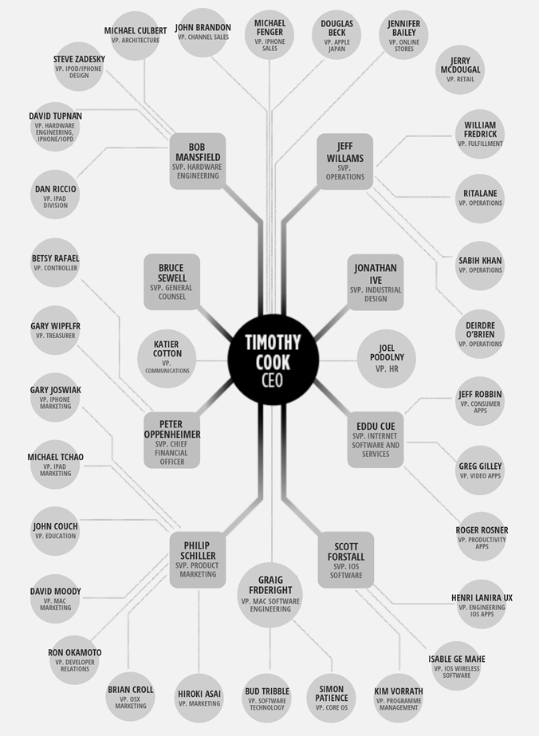

Figure 3: Apple's Organizational Structure Chart (Pen My Paper, n.d.)

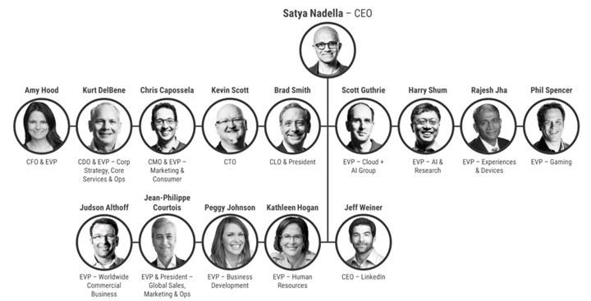

Figure 4: Microsoft's Organizational Structure Chart (CBInsights, n.d.)

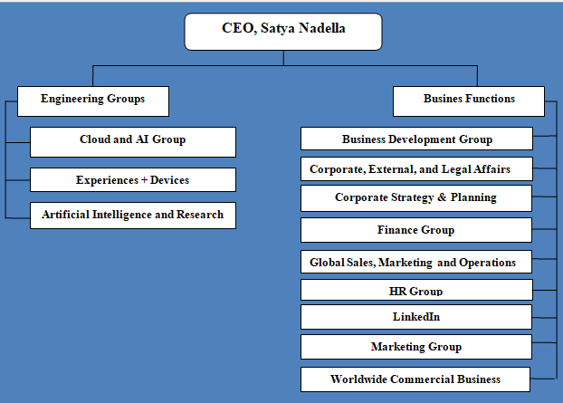

Figure 5: Departmentalization in Microsoft (Dudovskiy, 2019)

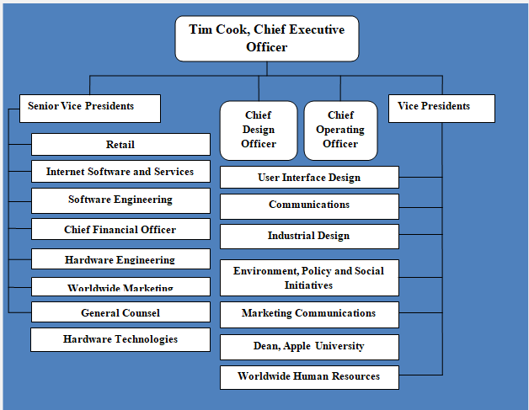

Figure 6: Departmentalization in Apple (Dudovskiy, 2021)

Appendix B: Group Task Report

|  |  |  |  |
| --- | --- | --- | --- |
| Name of Member | TP Number | Tasks | **Signature** |
| MOHAMMAD TABISH AMJAD ALI | TP062145 | * Abstract * Centralization/Decentralization * Introduction to Microsoft * Introduction to Apple * Conclusion * Proof-reading * Editing (the whole document) | **Tabish** |
| NAVEN SHRI A/L ARIVALAGAN | TP058295 | * Introduction to Apple * Departmentalization of Apple | **Naven** |
| MUHAMMAD AKMAL BIN KASHRY | TP062672 | * Introduction to Microsoft * Formalization | **Akmal** |
| KELVINJIT SINGH A/L LAKHBIR SINGH | TP056599 | * Departmentalization of Microsoft | **Kelvin** |
| ESLAM MAGDY REZK EBRAHIM HASSANIN | TP062816 | * Span of Control * Conclusion | **Eslam magdy rezk** |

# References

1000 Logos, 2021. *Apple Logo.* [Online]   
Available at: https://1000logos.net/apple-logo/  
[Accessed 8 February 2021].

Ahmer, A., 2019. *A Brief History of Apple Inc..* [Online]   
Available at: https://www.doersempire.com/a-brief-history-of-apple-inc/  
[Accessed 5 February 2021].

Ahmer, A., 2019. *Doers empire.* [Online]   
Available at: https://www.doersempire.com/a-brief-history-of-apple-inc/

Anon., 2020. *Business Conduct Policy.* [Online]   
Available at: https://s2.q4cdn.com/470004039/files/doc_downloads/Business-Conduct-Policy.pdf

Apple, 2021. *Apple Reports First Quarter Results.* [Online]   
Available at: https://www.apple.com/newsroom/2021/01/apple-reports-first-quarter-results/  
[Accessed 10 February 2021].

Bishop, T., 2014. *Microsoft cutting 18,000 jobs, 14% of company, in largest layoffs in its history.* [Online]   
Available at: https://www.geekwire.com/2014/breaking-microsoft-cutting-18000-jobs-next-year-14-workforce/  
[Accessed 7 February 2021].

CBInsights, n.d. *Microsoft Strategy Teardown: Cloud, AI, & Subscriptions And The Next Trillion-Dollar Company.* [Online]   
Available at: https://www.cbinsights.com/research/report/microsoft-strategy-teardown/  
[Accessed 29 January 2021].

Christensson, P., 2018. *Microsoft.* [Online]   
Available at: https://techterms.com/definition/microsoft  
[Accessed 28 January 2021].

Doshi, H. & Chek, L. H., 2017. *Organization and Management: An Extensive Analysis on Micosoft and Costco.* [Online]   
Available at: https://www.researchgate.net/publication/339954311_Organization_and_Management_An_Extensive_Analysis_on_Microsoft_and_Costco  
[Accessed 26 January 2021].

Dudovskiy, J., 2019. *Microsoft Organizational Structure: Divisional Structure with Focus on Innovation.* [Online]   
Available at: https://research-methodology.net/microsoft-organizational-structure-divisional-structure-with-focus-on-innovation/  
[Accessed 26 January 2021].

Dudovskiy, J., 2019. *Microsoft Organizational Structure: Divisional Structure with Focus on Innovation.* [Online]   
Available at: https://research-methodology.net/microsoft-organizational-structure-divisional-structure-with-focus-on-innovation/

Dudovskiy, J., 2019. *Microsoft SWOT Analysis.* [Online]   
Available at: https://research-methodology.net/microsoft-swot-analysis-2-2/  
[Accessed 28 January 2021].

Dudovskiy, J., 2021. *Apple Organizational Structure: a brief overview.* [Online]   
Available at: https://research-methodology.net/apple-organizational-structure-a-hierarchical-structure-that-may-change-in-near-future/  
[Accessed 10 February 2021].

Favaro, K., 2013. *Looking Inside the Latest Reorganization of Microsoft.* [Online]   
Available at: https://www.strategy-business.com/blog/Looking-Inside-the-Latest-Reorganization-of-Microsoft?gko=e4e80  
[Accessed 25 January 2021].

FindLaw, 2010. *Business Conduct Policy - Apple Inc..* [Online]   
Available at: https://corporate.findlaw.com/contracts/operations/business-conduct-policy-apple-inc.html  
[Accessed 10 February 2021].

Graham, D., 2016. *How is work-life balance at Apple?.* [Online]   
Available at: https://www.quora.com/How-is-work-life-balance-at-Apple/answer/David-Graham-149

IGI Global, n.d. *What is Formalization.* [Online]   
Available at: https://www.igi-global.com/dictionary/leading-organizational-dynamics-business-firms/11409  
[Accessed 25 January 2021].

Kovach, S., 2013. *LEAKED EMAIL: Apple's Lawyers Ask All Employees To Review The Company's Code of Conduct.* [Online]   
Available at: https://www.businessinsider.com/apple-employees-review-code-of-conduct-2013-11  
[Accessed 10 February 2021].

Lombardo, J., 2018. *Microsoft Corporation's Organizational Structure & Its Characteristics (An Analysis).* [Online]   
Available at: http://panmore.com/microsoft-corporation-organizational-structure-characteristics-analysis  
[Accessed 10 February 2021].

Lorenzetti, L., 2015. *Why Apple’s CEO Tim Cook probably has way too many direct reports.* [Online]   
Available at: https://fortune.com/2015/07/08/apple-cook-direct-reports/  
[Accessed 7 February 2021].

Meyer, P., 2019. *Apple Inc.'s Organizational Structure & Its Characteristics (An Analysis).* [Online]   
Available at: http://panmore.com/apple-inc-organizational-structure-features-pros-cons  
[Accessed 1 February 2021].

Microsoft, 2020. *Annual Report 2020.* [Online]   
Available at: https://www.microsoft.com/investor/reports/ar20/index.html  
[Accessed 12 February 2021].

Microsoft, 2020. *Legal Policies.* [Online]   
Available at: https://careers.microsoft.com/us/en/legalpolicies  
[Accessed 7 February 2021].

Microsoft, n.d. *Pres Release & Webcast.* [Online]   
Available at: https://www.microsoft.com/en-us/Investor/earnings/FY-2021-Q1/press-release-webcast#:~:text=%E2%80%9CWe%20continue%20to%20invest%20against,drive%20long%2Dterm%20growth.%E2%80%9D&text=Microsoft%20returned%20%249.5%20billion%20to,quarter%20of%20fiscal%20year  
[Accessed 12 February 2021].

Noble Academy, 2020. *How Satya Nadella Led Microsoft through a Corprat Turnaround.* [Online]   
Available at: https://academy.nobl.io/how-satya-nadella-led-microsoft-through-a-corporate-turnaround/  
[Accessed 28 January 2021].

Okusolubo, G., 2020. *Organizational Analysis (A Case Study of Apple Inc.).* [Online]   
Available at: https://www.researchgate.net/publication/340950157_Organizational_Analysis_A_Case_Study_of_Apple_Inc  
[Accessed 28 January 2021].

OrgChart, 2015. *Importance of Span of Control & Organizational Structure.* [Online]   
Available at: https://www.orgchartpro.com/span-of-control-and-organizational-structure/  
[Accessed 10 February 2021].

Pen My Paper, n.d. *Organizational Structure of Apple.* [Online]   
Available at: https://penmypaper.com/knowledge-base/apple-organizational-structure  
[Accessed 29 January 2021].

Prachi, M., 2018. *Centralization.* [Online]   
Available at: https://theinvestorsbook.com/centralization.html  
[Accessed 24 January 2021].

Prachi, M., 2018. *Centralization.* [Online]   
Available at: https://theinvestorsbook.com/centralization.html  
[Accessed 28 January 2021].

Reiff, N., 2021. *How Microsoft Makes Money.* [Online]   
Available at: https://www.investopedia.com/how-microsoft-makes-money-4798809  
[Accessed 12 February 2021].

Ross, S., 2020. *Apple vs. Microsoft Business Model: What's the Difference.* [Online]   
Available at: https://www.investopedia.com/articles/markets/111015/apple-vs-microsoft-vs-google-how-their-business-models-compare.asp  
[Accessed 11 February 2021].

Sisk, A., 2018. *Elements of Organizational Structure.* [Online]   
Available at: https://bizfluent.com/info-8623691-importance-hierarchy-workplace.html  
[Accessed 8 2 2021].

StudyCorgi, 2020. *Microsoft Corporation's Organizational Behviors.* [Online]   
Available at: https://studycorgi.com/microsoft-corporations-organizational-behaviours/  
[Accessed 10 February 2021].

UKEssays, 2018. *Apple Inc Continued To Thrive Commerce Essay.* [Online]   
Available at: https://www.ukessays.com/essays/commerce/apple-inc-continued-to-thrive-commerce-essay.php  
[Accessed 7 February 2021].

UKEssays, 2018. *Apple Inc. Continued To Thrive Commerce Essay.* [Online]   
Available at: https://www.ukessays.com/essays/commerce/apple-inc-continued-to-thrive-commerce-essay.php#:~:text=From%20the%20organization%20structure%2C%20we,stage%20to%20stage%20until%20completion.  
[Accessed 11 February 2021].

VOZZA, S., 2017. *Fast Company.* [Online]   
Available at: https://www.fastcompany.com/3068771/how-employees-at-apple-and-google-are-more-productive

Vozza, S., 2017. *Why Employees At Apple And Google Are More Productive.* [Online]   
Available at: https://www.fastcompany.com/3068771/how-employees-at-apple-and-google-are-more-productive  
[Accessed 8 February 2021].

Warren, T., 2012. *Microsoft unveils its new logo, the first major change in 25 years.* [Online]   
Available at: https://www.theverge.com/2012/8/23/3262517/microsoft-new-logo  
[Accessed 4 February 2021].